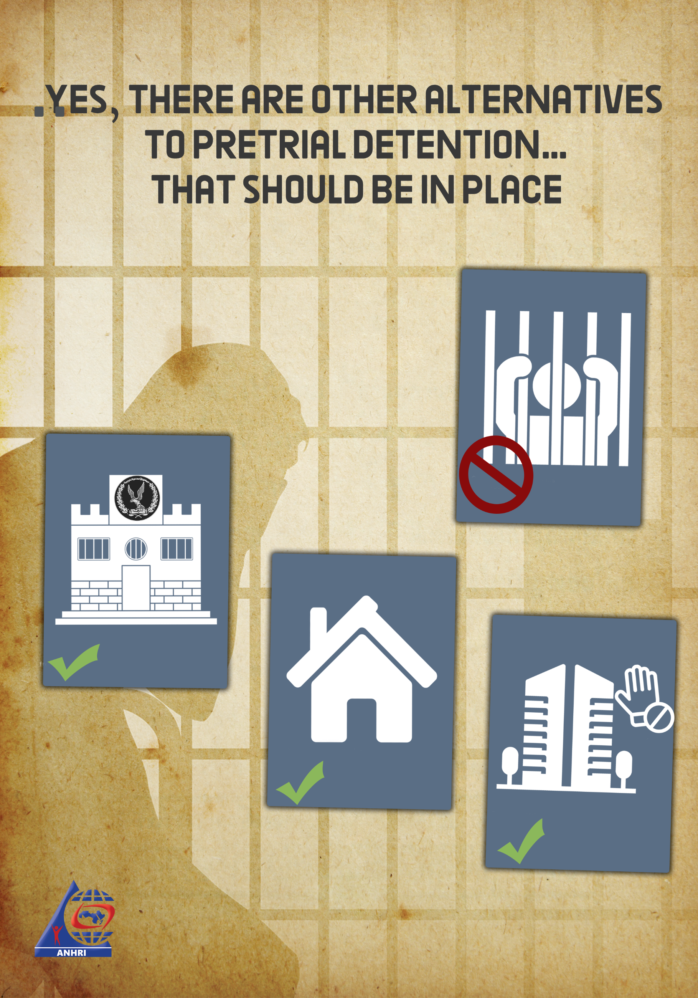

Yes, there are other alternatives to pretrial detention…
that should be in place
Introduction
Lawmakers in Egypt tackled the necessity of limiting the use of pretrial detention; since it shouldn’t be considered a tool of punishment in itself although being- in nature- combined with the anti-freedom penalties. It is an established principle that "no penalty can be imposed without a court ruling of conviction" and that the accused person is presumed innocent until proven guilty. However, we find that the Public Prosecution "State Security Prosecution" has oddly used pretrial detention in an extensive way, as if there is no alternative to incarceration except that the suspect serves a long period in jail pending a pretrial detention order that can be extended to reach two years, which is the maximum limit for pretrial detention period. Also, in many cases defendants exceed the two-year limit, such as the case of Shady Habash who died in prison while serving an illegal remand detention order. Several other legal alternatives for the renewal of pretrial detention are hence being left and ignored without any feasibility or usefulness.
Even after the outbreak of the life-threatening coronavirus pandemic, the Public Prosecution in Egypt, unlike many other countries in the world, didn’t use its authority to enforce such alternatives or legal measures for defendants- supposedly innocent until proven guilty- to prevent the spread of COVID-19 infections, reduce prison overcrowding during the pandemic, and preserve the lives of citizens, especially those who are supposed to be blessed with the presumption of innocence.
Lawmakers encircled the renewal of pretrial detention with several safeguards and regulations, as follows:
Pretrial detention guarantees:
Legislators put a set of several guarantees in case it is necessary to extend the pretrial detention period for defendants in accordance with Article 134 of the Criminal Procedure Law, which states that: " The investigating judge, after questioning the accused or if he escapes in case the crime is a felony or a misdemeanor, shall punish him with imprisonment for a period of not less than one year, and if the evidence is sufficient, he shall order to hold the accused in pretrial detention"; specifying certain circumstances and reasons for a prosecutor to request that a detainee be held on remand. These circumstances are:
(1) When crimes are committed in flagrante delicto (when the suspect was caught in the act of committing the offense)
(2) When there is a fear of the suspect fleeing or absconding
(3) When there is a fear that the interests of the investigation will be compromised either by influencing the victim or witnesses or tampering with evidence or by reaching agreements with the remaining accused to distort the truth
(4) When it is necessary to prevent grossly compromising security and public order as a result of the magnitude of the crime.
The accused may be held in remand if he does not have a known address or place of residence in Egypt and the crime is either a misdemeanor or a felony that is punishable with imprisonment.
However, in many of the cases considered before the State Security Prosecution, the prosecutor based his accusation only on the investigation record conducted by the police officer in the absence of any supporting facts or sufficient evidence. Also, all the defendants ordered to be detained have a permanent place of residence in Egypt, and there is no fear of the suspect fleeing the country since it's possible to issue a travel ban against him.
The Public Prosecution is the only authority in charge of the criminal litigation against defendants, and the only witnesses to the investigation record are the police officers, while there is no physical evidence. Most of the defendants don’t know each other or have any means of communication among them, so there is no fear that the interests of the investigation will be compromised either by influencing the victim or witnesses or tampering with evidence, which is most probably nonsense in many cases. Moreover, many of the defendants who are randomly arrested are not accused of a certain crime or proved to be implicated in a certain incident, and hence, the "gross breach of security and public order as a result of the magnitude of the crime" cannot be applicable here. The Public Prosecution has to make sure of the validity of the allegations made by the officer who conducted the investigation.
Having mentioned all the above-mentioned rules and circumstances, the Prosecution continues to hold suspects and defendants in pretrial detention despite the fact that Article 134 states that it's not permissible to order the continuation of the accused's detention except after questioning him regarding the charges pressed against him. But what happens in fact is that the accused attends only one investigation session, during which he is faced with the accusations which he denies by replying "I don’t know" or "This didn’t happen". The prosecutor usually doesn’t address the basis or the reasons behind the accusations that lead to either the defendant's detention or his release under any guarantee that the Public Prosecution deems necessary. But, and as usual, most pretrial detention renewal orders are issued under no basis and without interrogating the accused in accordance with the Criminal Procedure Code.
Question: What is the solution now?
Answer: If is the authority is keen on establishing the rule of law, there are alternatives to pretrial detention as stipulated in Article 201 of the Criminal Procedure Code: -
The detention order issued by the Public Prosecution may only be valid for four days following the day of arrest or delivering the accused person - if such person has already been arrested- to the Public Prosecution.
Under this article, authorities reviewing the pretrial detention of an individual are empowered to consider probationary measures instead of detention. These measures include:-
(1) Compelling the accused person not to leave his home or country
(2) Compelling the accused person to present himself/herself at the police station at specific times
(3) Prohibiting the accused person from going to certain places.
If the accused violates these obligations imposed by such measures, he may be remanded in custody.
The same rules prescribed with regard to pretrial detention shall also be applicable in terms of the duration of the measure, its extension, and its maximum limit.
Arrest and detention orders issued by the Public Prosecution may not be executed after six months of their issue date, unless endorsed by the Public Prosecution for another period.
As clearly stipulated in the Criminal Procedure Law, it is permissible for the authorities in charge of reviewing the pretrial detention to consider several alternatives so that the accused would not be harmed as a result of his remand custody. These alternatives include: compelling the accused person not to leave his home or country (barring him from traveling), and to present himself at the police station at specific times, a precautionary measure that can be considered as an alternative to prolonged pretrial detention, upon a decision issued by the criminal court convened in the counseling room. However, this decision (probationary release) can be appealed or challenged by the Public Prosecution, leading to the accused being ordered to be re-detained without giving any reasons or justifications. Another alternative to pretrial detention may include: prohibiting the accused person from going to certain places as determined by the same authority. All of these aforementioned precautionary measures can be used by the Public Prosecution as an alternative to remand detention, which shouldn't be extensively except in necessary cases.
In the following lines, we're going to outline some examples of cases where defendants are being charged and detained for a period of two years without undertaking any of the above-mentioned alternatives or measures. Other examples include cases where defendants are ordered to be released with precautionary measures (appearing before the police station at specific times), and others where defendants received a release order under the guarantee of their place of residence after rescinding such measures, but the case hasn’t yet been referred to the court or the Public Prosecution to uphold the decision or rule the inadmissibility of the criminal lawsuit or to order the release of defendants on bail:
Case No. 977 of 2017 State Security
Defendants:
1- Journalist Hossam Abdel-Monji Galal, aka "Hossam El-Sweify"
2- Photojournalist Mohamed Ahmed Ashry, aka "Islam Ashry"
3- Youtuber Ahmed Mohamed Saad Mohamed, aka "Ahmed El-Sharnoubi"
4- Mohamed Al-Qassas, a deputy head of a political party
5- Journalist Ahmed Abdel Aziz, and others…
Some of these defendants were ordered to be detained for two years, others for one year and a half, while others were ordered to be released with precautionary measures, and after 2 years they were ordered to be released under the guarantee of their place of residence, before they were recycled pending a new case and continued to be held in remand.
Case No. 400 of 2018 State Security
Defendants:
1- Dr. Abdel Moneim Abu El Fotouh, head of a political party.
2- Moaz Najah Mansour El-Sharkawy, a former vice president of the Tanta University Student Union…
In addition to others who were arrested and added to the terrorism list upon a decision published in the Official Gazette. As for Abdel-Moneim Abu El-Fotouh and his deputy Mohamed Al-Qassas, they have been recycled and added to a new case after exceeding the two-year pretrial detention limit. Their case hasn’t yet been referred to the court and hence they are still being held in remand detention.
Case No. 621 of 2018 State Security
Defendants:
1- YouTuber Mohamed Khaled Mohamed Yassin, aka "Meagifir"
2- Lawyer and writer Ahmed Sabry Abu Alam
3- Mona Mahmoud Abdel-Gawad, a housewife
4- Vlogger Mohamed Ibrahim Mohamed Radwan, aka "Oxygen"
5- Shadi Hussein Abu Zeid, a satirical program correspondent
6- Dr. Shadi Tariq Al-Ghazali Harb
7- Dr. Walid Ahmed Shawky
8- Sayed Ali Abdel-Aal, a lawyer.
9- Ayman Abdel Moaty Abdel Rasoul, a linguist and proof-reader
Some of these defendants were ordered to be released upon rescinding their precautionary measures making the release order a binding decision. Other defendant has been recycled and added to a new case. The court hasn’t yet considered the case even after passing two years, and the defendants haven’t yet received a release order under any financial or personal guarantee.
Case No. 441 of 2018 State Security
Defendants:
1- Vlogger Wael Ibrahim Abbas
2- Adel Ahmed Sabry, a chief editor of a newspaper
3- Journalist Moataz Mohamed Shams El-Din
4- Editor Moamen Hassan Abdullah
5- Video editor Mohamed Mahmoud Ezzat
6- Mustafa Al-Aasar
7- Hassan Al-Banna and others
After two years since the opening of the case, some of these defendants were ordered to be released after rescinding their precautionary measures, and others are still serving their precautionary measures, while others are still being held in pretrial detention even after exceeding the two-year limit. The case hasn’t also been referred to the court to be considered.
Case No. 718 of 2018 State Security
Defendants:
1- Asmaa Abdel-Hamid
2- Youssef Ahmed Sayed
3- Abeer Al-Safty
4- Haitham Fawzi Muhammadin and others
The case was started in the aftermath of increasing the prices of Metro tickets. Some of its defendants were ordered to be released under the guarantee of their place of residence, and others received precautionary measures as an alternative to their pretrial detention. Two of them have been recycled and added to new cases. The Prosecution hasn’t yet referred these cases to trial or ordered the reversal of the defendants' precautionary measures and accordingly ordered their release.
Among the hundreds, if not thousands, of prisoners of conscience, who are still remanded in custody- although they should be released (or at least received a probationary release), in implementation of the rule “the accused is innocent until proven guilty” or as a protective measure against the spread of the coronavirus pandemic in prison:
- University professors and academics: Dr. Hazem Hosni, Patrick George
- Lawyers: Ziyad Al-Alimi, Mohamed Ramadan, Mahinor El-Masry, Amr Imam, Haitham Muhammadin, Muhammad Al-Baqer
- Journalists: Hisham Fouad, Adel Sabry, Shaima Sami, Moataz Wadnan, Israa Abdel-Fattah, Solafa Magdy, Hossam El-Sayyad, Hossam Mounes, Khaled Dawoud, Mahmoud Hussein, Alia Awad, Mostafa Saqr
- Professionals: Engineer Yehia Hussein Abdel-Hadi, Hassan Barbary, Ahmed Tammam, Ayman Abdel-Moaty, Mohamed Al-Qassas, Marwa Arafa, Ahmed Badawi, Ola Al-Qaradawi, Abdel Nasser Ismail
- Judges: Hisham Geneina
- Former or potential presidential candidates: Abdel-Moneim Abu El Fotouh, Ahmed Kansoah
- Technicians and Bloggers: Alaa Abdel-Fattah, Mohamed Oxygen, Shadi Abu Zeid
Conclusion
It is clear that not every accusation- including joining, belonging to or participating in a terrorist group- leveled against suspects by the State Security Prosecution in accordance with the Anti-Terrorism Law is a substantiated accusation, as we saw in the above-mentioned cases, to mention but a few. We believe that the Public Prosecution is adopting this method in order to punish opinion holders and dissidents who criticize the state authorities' performance and policies, using a quasi-legal means, instead of the arbitrary arrest orders and the circumvention of the Criminal Procedure Law represented in the prolonged pretrial detention. In case any of such violations is observed, the Prosecution has to implement the provisions of the law that guarantees the right of a suspect to legal counsel and a defense, but this unfortunately doesn’t happen.
Recommendations
- We urge the Public Prosecutor to undertake all the necessary legal measures in cases which include no supporting facts or sufficient evidence that proves the conviction of defendants.
- We call on the Parliament and the Legislative Committee to amend the terms/period of pretrial detention stipulated in the Criminal Procedure Code.
- We call on the Public Prosecution to respect and implement the law and the Constitution without undermining the rights and freedoms of citizens or wasting their lives.
- We call on the Public Prosecutor to promptly adjudicate the cases where defendants are being held in remand detention, so that it wouldn’t be turned into an anti-freedom penalty.

:

