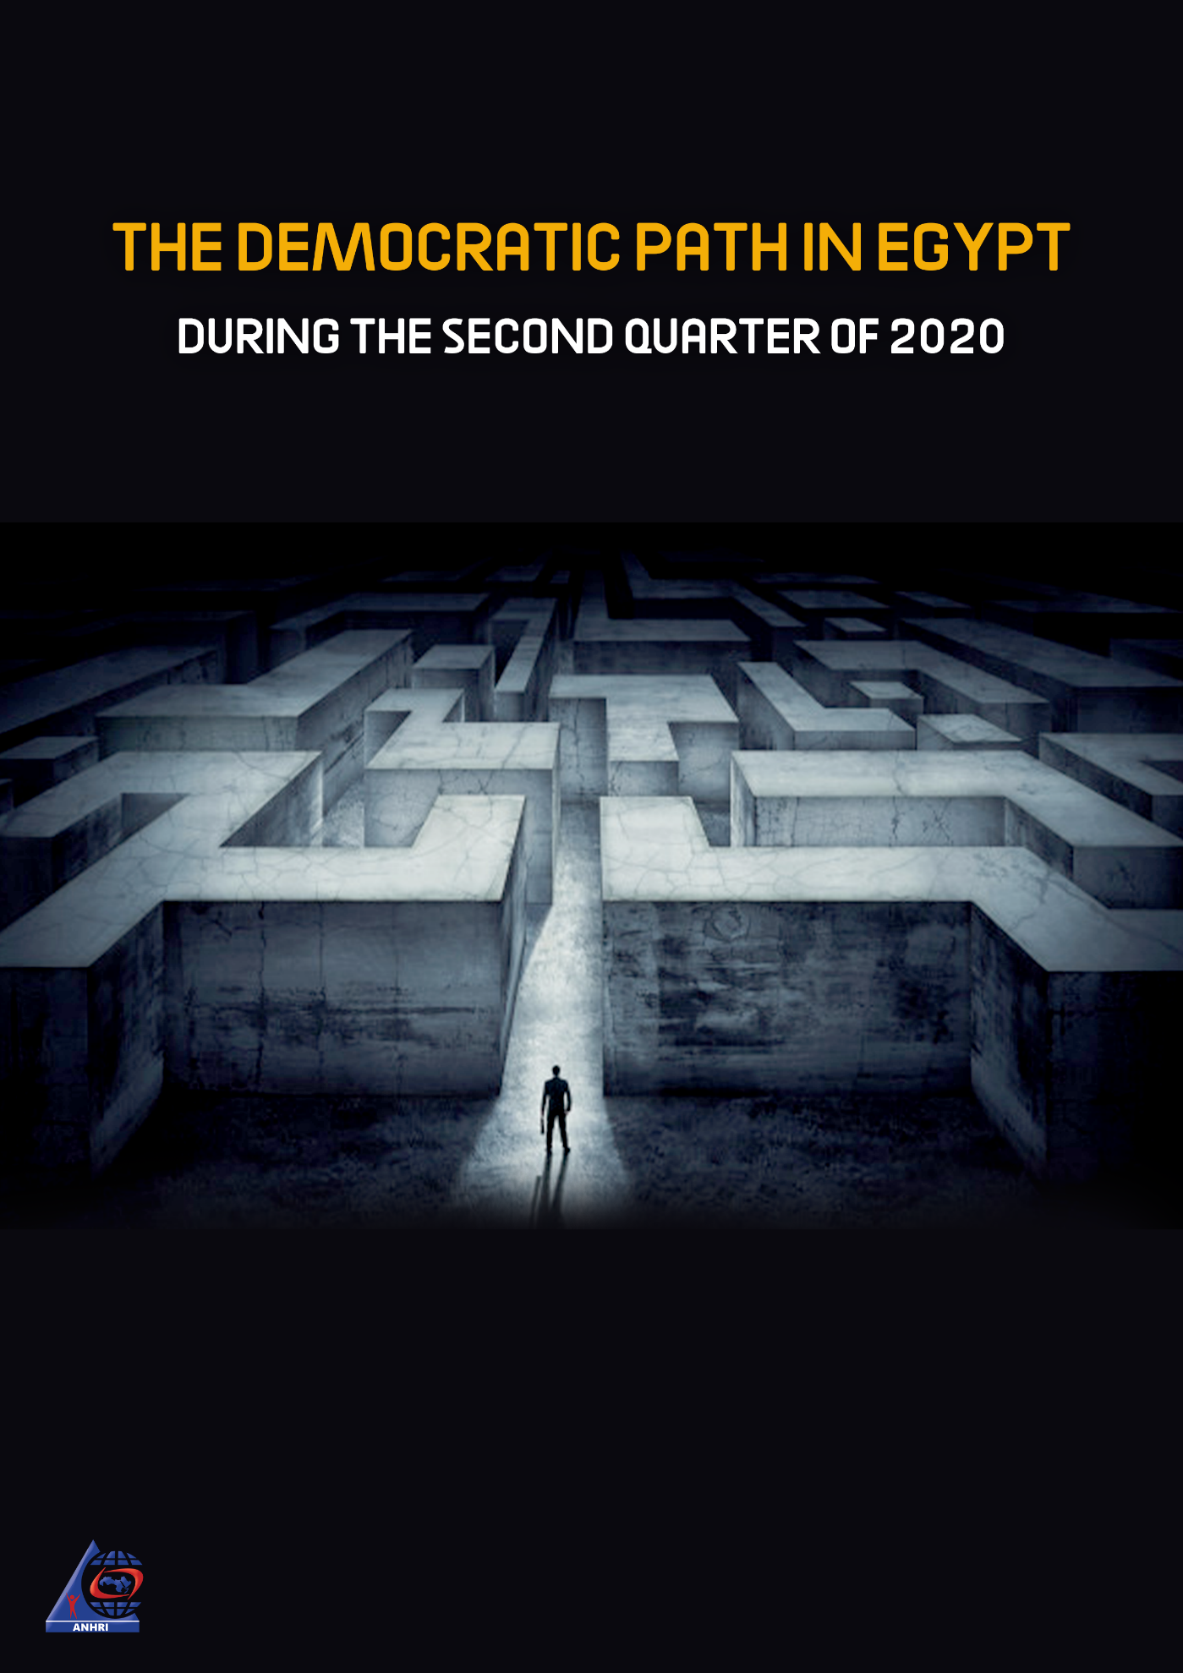

The Arabic Network for Human Rights Information (ANHRI)
"Lawyers for Democracy” Initiative

The Democratic Path in Egypt
during the Second Quarter of 2020

Before we begin:
The Democratic Path is a report that is launched by the Arabic Network for Human Rights Information (ANHRI) every three months, i.e. quarterly, as part of the “Lawyers for Democracy” initiative which was launched in 2014 to monitor the democratic process in Egypt.
In addition to the reports periodically issued to monitor the state of democracy, ANHRI issued annual periodic reports to monitor the democratic path from 2014 till 2019. You can be accessed them through the “Reports and Studies” section on ANHRI’s website by clicking on the following link:
https://www.anhri.info/?cat=14&lang=en

Introduction
The 2nd Quarter 2020 Democratic Path report covers a number of manifold issues and incidents, including the first death anniversary of Egypt's former President Mohamed Morsi, who died in court while standing trial in the case publicly known as "spying for Hamas'. The report also tackles the Supreme Judicial Council's decision to suspend court proceedings and the transfer of defendants from their jail to the courthouse or the competent prosecutions due to the spread of the Coronavirus (COVID-19) pandemic, a move that has led to the postponement of all cases considered before the judiciary in the country. The coronavirus outbreak didn’t prevent the authorities from proceeding with their crackdown on activists, human rights defenders and opinion holders. During the last month of the second quarter of the year, journalists Mohamed Monir and Awni Nafea were arrested and taken to the Supreme State Security Prosecution for investigation, after they posted comments on their Facebook pages criticizing the Egyptian government in dealing with the coronavirus crisis. The security forces also arrested human rights lawyer Sanaa Seif outside the Public Prosecutor's Office while she was attempting to lodge an official complaint about the assault she and her family- sister Mona Seif and mother professor Laila Suef- had endured after demanding to be allowed to receive a written letter from her brother Alaa Abdel-Fattah, who is being detained over a state security case.
The period covered by the report (April, May and June 2020) witnessed 76 protest activities which were organized by the different political forces. Of which, social and labor protests were at the forefront with 41 protests, followed by the Muslim Brotherhood (MB) and the National Alliance to Support Legitimacy (NASL)'s activities with 30 protests staged during that period.
Military trials of civilians also continued in the second quarter of the year; as among the 46 trials held during the reporting period, there were 3 military trials for 827 citizens.
Violations of media freedoms have not ceased during this period as well; with 40 cases of violations recorded, most notably with respect to the investigations conducted by the competent prosecutions and during the detention renewal sessions, which amounted to 14 violations during the period covered by the report.
On the other hand, the number of terrorist operations has continued to decline compared to the previous years; as the second quarter of 2020 witnessed only 8 terrorist operations, three of which were carried out using improvised explosive devices while the security forces managed to thwart the other five operations.

The details of the state of the democratic path during the 2nd quarter of 2020 are outlined, in numbers and percentages, as follows:
First: Protest events
During the second quarter of the year, the various forces organized 76 different events, and their distribution was as follows:
* Social and labor protests: 41 protest events
* Muslim Brotherhood (MB) and the National Alliance to Support Legitimacy (NASL): 30
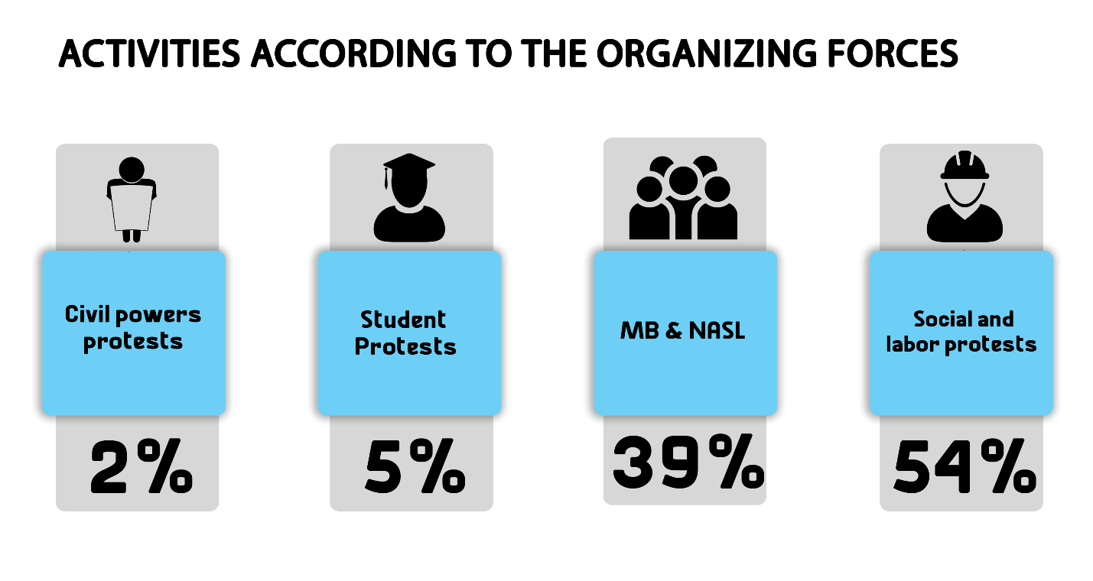
* Student protests: 4 * Civil powers protests: 1

The month of May came first in witnessing the largest number of protest events with 29 different protests, as shown in the following table:
April | May | June | Total
76 | 23 | 29 | 24

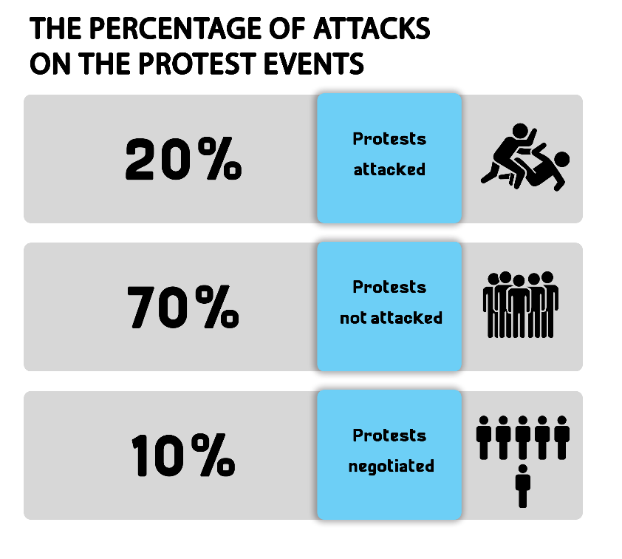
Out of these different events, 15 were attacked by security forces, 53 passed without attacks, and 8 labor and social protests were resolved after negotiations.
Labor and Social protests:
The second quarter of 2020 witnessed 41 different social and labor protests; eight of which were attacked by security forces, whereas 26 passed without interference, and 7 were resolved after negotiations with their organizers.
The most important demands brought by the social and labor protests:
- Ismailia Sporting club employees protested the non-receipt of their financial dues
- A number of workers protested their arbitrary dismissal from work and demanded the disbursement of their financial dues
- A number of workers demanded installation in their jobs
- Dishna Village residents protested water cuts for 10 days
- Dr. Laila Suef staged a sit-in outside the Tora Prison gate demanding to receive a letter a letter from her detained son
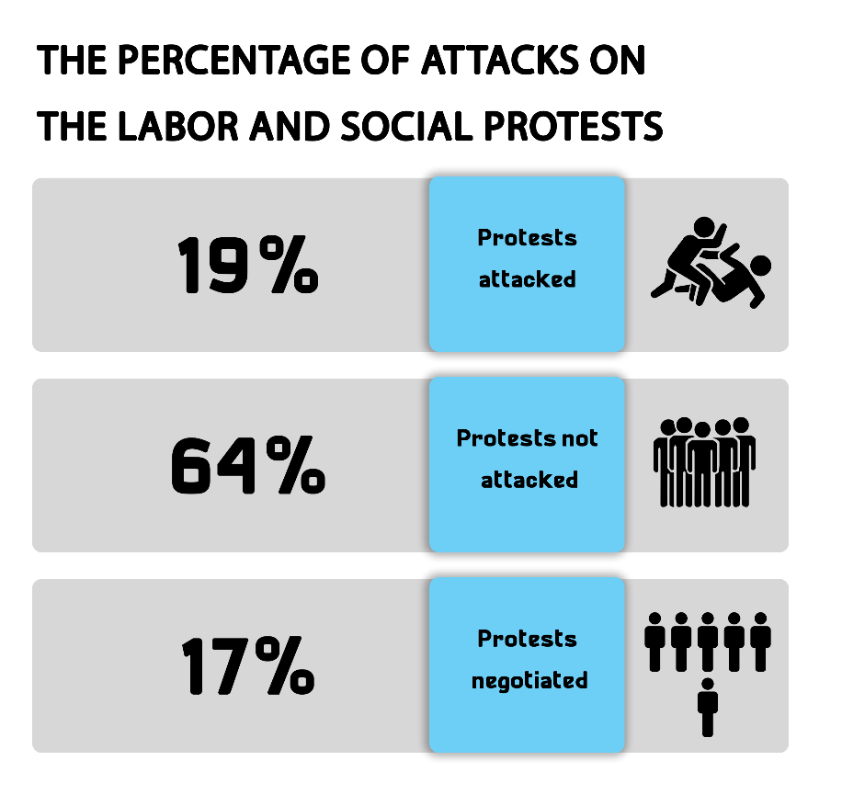
- A number of nurses and medical staff protested the health conditions in hospitals and demanded to conduct a coronavirus test for them.

MB and NASL protest activities:
The second quarter of 2020 witnessed the Muslim Brotherhood (MB) and the National Alliance to Support Legitimacy (NASL) organizing 30 different protests, including 7 that were attacked by the security forces and 28 that were left without security intervention, while none of them was subject to negotiation.
The most important demands raised by Muslim Brotherhood and the National Alliance to Support Legitimacy:
- Commemoration of the first anniversary of the death of former President Mohamed Morsi in the courtroom during his trial over the "Spying for Hamas" case.
- Demanding the release of detainees and improvements to prison conditions.
- Demanding to topple what they described as the military rule.
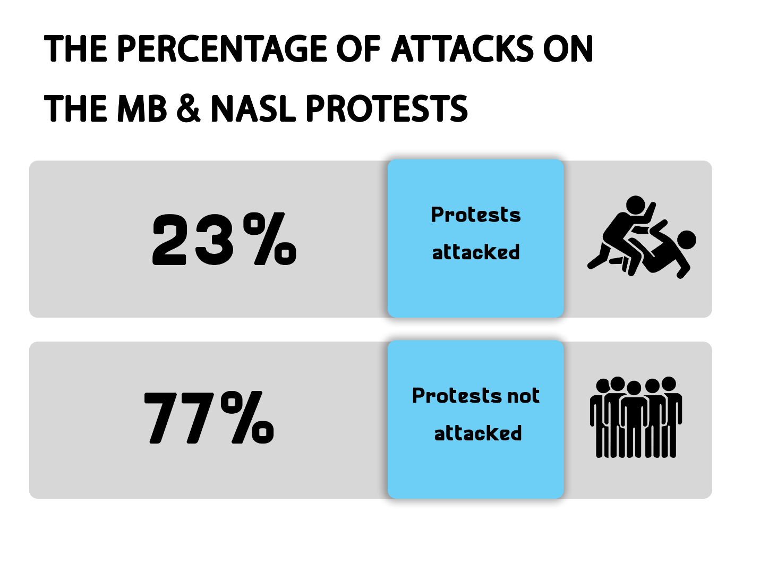

Student activities:
The second quarter of 2020 witnessed only four protest activities organized by students, three of them were left without any security intervention, while the security forces managed to resolve one protest through negotiation.
Student protests’ main demands:
- A number of university students objected to the internet-based examination system and demanded to replace it with a research project
- A number of students and their parents protested the attitude of a bookshop's owner in Tanta city after he cheated and deceived them by asking for more money in exchange for preparing research projects for them, demanding from the security services to arrest him.
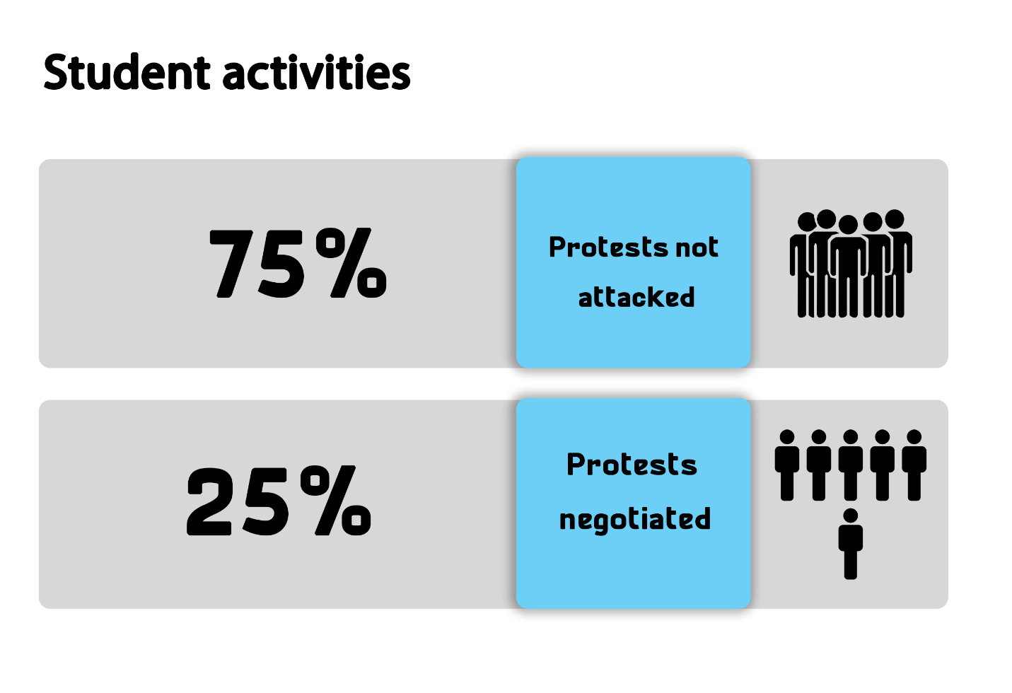

Civil Powers protest events:
The second quarter of 2020 witnessed only one protest took place in Cairo. The protest was organized by the Tagammu Party's headquarters in Downtown to celebrate the occasion of the Labor Day.

Second: Trials
- Ongoing trials:
The second quarter of 2020 witnessed 46 trial cases that are being considered before the Egyptian judiciary. Of these, there were 17 rulings of conviction, two acquittals and two death sentences against 11 defendants.
The distribution of the 46 ongoing trials is as follows:
* 32 trials for the MB & NASL.
* 7 trials of the civil and democratic powers.
* 3 trials for Mubarak’s regime’s affiliates.
* 1 trial for affiliates of the post June 30th regime
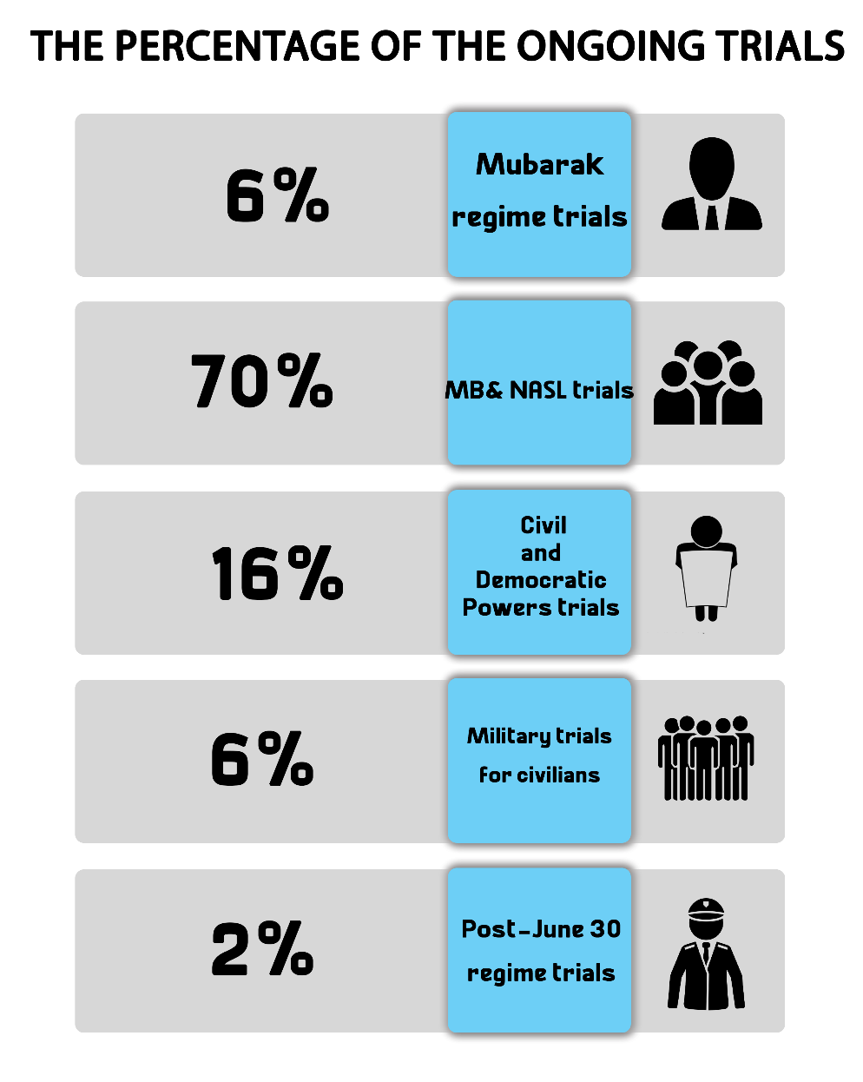
* The military judiciary considered 3 trials for 827 civilians

The most prominent trials of MB and NASL are:
The cases known in the media as: (Talat Harb incidents, Isis's Upper Egypt Province, Rabaa Sit-in dispersal, arson of Al-Atamna Police Station, arson of Kafr Hakim Church, Helwan Brigades, Al-Nusra Front, Al-Moski violence incidents, raiding Al-Arab Police Station, May 15 violence incidents, raiding Al-Tebbein Police Station, Al-Masara Cell, raiding Kerdasa Police Station, Al-Maghara incidents)
The most prominent trials of Mubarak regime figures are:
The cases known in the media as: (The Green Belt, customs corruption and the License Plates).
The most prominent trials of civil and democratic powers are:
The cases known in the media as: (The Oppressed of Downtown, The trial of Al-Warraq Island residents, The Cabinet incidents, Trial of lawyer Zyiad El-Eleimy, the seizure of Dr. Hassan Nafaa's funds, and the trial of engineer Mamdouh Hamza).
The most prominent trials of post- June 30th regime’s affiliates are:
The cases known in the media as: (The Trial of Alexandria’s deputy governor on bribery charges)
The Military Trials of civilians:
In the second quarter of 2020, the military judiciary considered 3 ongoing trials for 827 civilians.
- Sentences
During the reporting period, there were 17 convictions and 2 acquittals. The details are as follows:
Convictions:
During the second quarter of the year, the Egyptian judiciary issued 17 convictions, distributed as follows:
* 15 rulings against the Muslim Brotherhood (MB) and the National Alliance for the Support of Legitimacy (NASL).
* Two rulings against defendants in the civil democratic forces’ cases

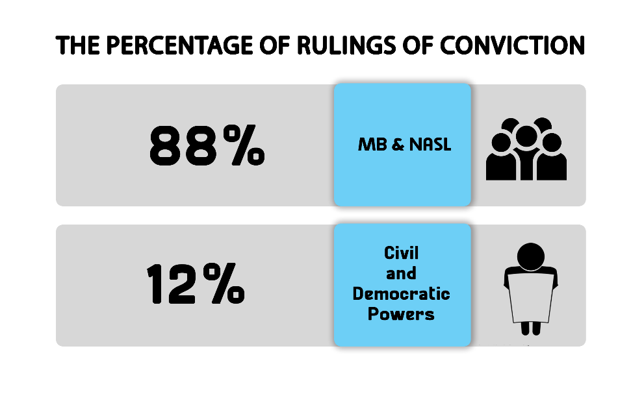
Acquittals:
During the first quarter of the year, two acquittals had been handed down for the MB and NASL affiliates.

Death sentences
Four death sentences were issued against 11 defendants during the second quarter of 2020, in addition to the execution of Abdel Rahim el-Mesmary in the case of "Al-Wahat checkpoint", as shown in the following table:
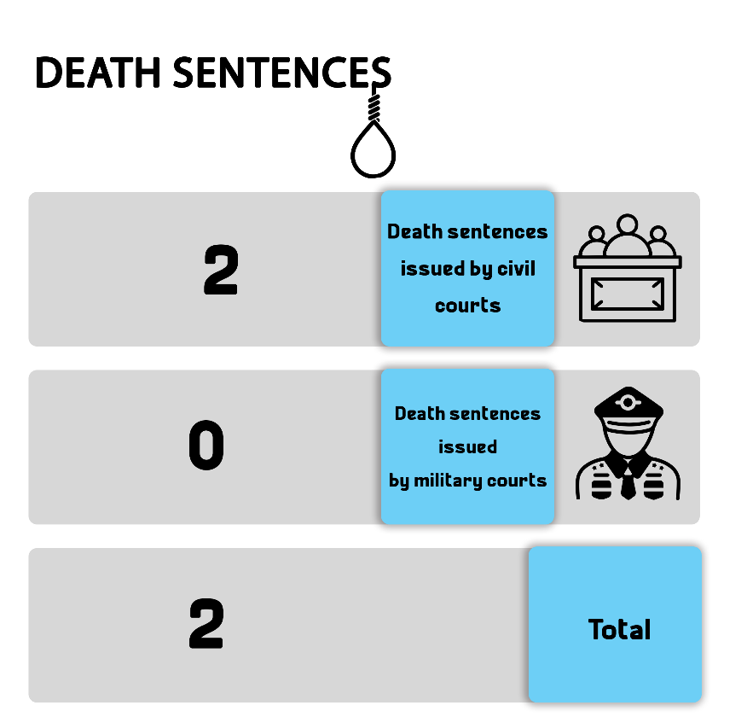
1- Rulings
Total | Death sentences issued by military courts | Death sentences issued by civil courts
2 | - | 2

2- Defendants
Total (Number of defendants) | Number of defendants upheld by the Court of Cassation to be executed | Number of defendants upheld by the Mufti to be executed | Number of defendants referred to the Mufti
11 | 8 | 3 | -- | Civil
-- | -- | -- | -- | Military
11 | 8 | 3 | -- | Total

3- Death sentences executed:
The Prisons Authority sector executed, in the month of June, one death sentence handed down against one defendant:
On 27 June 2020, the Egyptian authorities carried out the death sentence that was issued by the Military Court against terrorist Abdel Rahim el-Mesmary in the case publicly known as "Al-Wahat checkpoint".

Third: Violence and Terrorism
The second quarter of 2020 witnessed a total of 8 terrorist operations in Egypt’s different governorates, along with 4 counter-terrorism operations, detailed as follows:
- Terrorist operations:
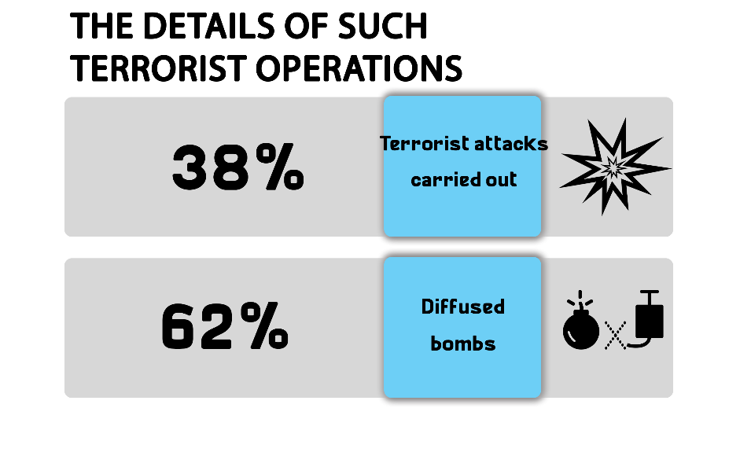
Eight terrorist attacks took place in the second quarter of the year; three of them had been carried out, while the security forces succeeded in thwarting the five others. The operations resulted in the killing and injury of 34 people.

The following table shows the percentage of terrorist operations and counter-terrorism ones:
Total | Operations thwarted | Operations carried out | Months
4 | 3 | 1 | April
3 | 2 | 1 | May
1 | 0 | 1 | June
8 | 5 | 3 | Total

The following table shows the number of terrorist operations and their distribution in the different governorates:
Total | Operations thwarted | Operations carried out | Governorates
8 | 5 | 3 | North Sinai
8 | 5 | 3 | Total

– These operations had resulted in 34 killed and wounded.
The following table shows the number of killed and wounded and their distribution:
Total | Terrorists | Security forces | Civilians
17 | 0 | 17 | 0 | Number of killed
17 | 0 | 17 | 0 | Number of wounded
34 | 0 | 34 | 0 | Total

- Counter-Terrorism Operations
During the second quarter of the year, there were 25 preemptive attacks by the security forces which targeted what they described as terrorism hubs, resulting in the killing of 201, the wounding of 16 and the arrest of 266 others.
The following table shows the number of dead and injured
Total | Those targeted | Security forces
201 | 195 | 6 | Number of killed
16 | 0 | 16 | Number of wounded
217 | 195 | 22 | Total

Fourth: Attack on Freedom of Expression and Media Freedoms
The second quarter of the year witnessed 34 various violations against freedom of expression and media freedoms.
The following table shows the number of violations took place throughout the first three months of 2020:
Months | Number of violations
15 | April
12 | May
13 | June
40 | Total

Details are as follows:
Number of violations | Kind of violation
14 | Investigations and detention renewal sessions
8 | Banning websites
7 | Arrest and/or detention
4 | Administrative penalties (fines)
3 | Ban from media coverage
2 | Ban from appearing on media
1 | Removal of press articles/reports
1 | Physical and verbal attacks

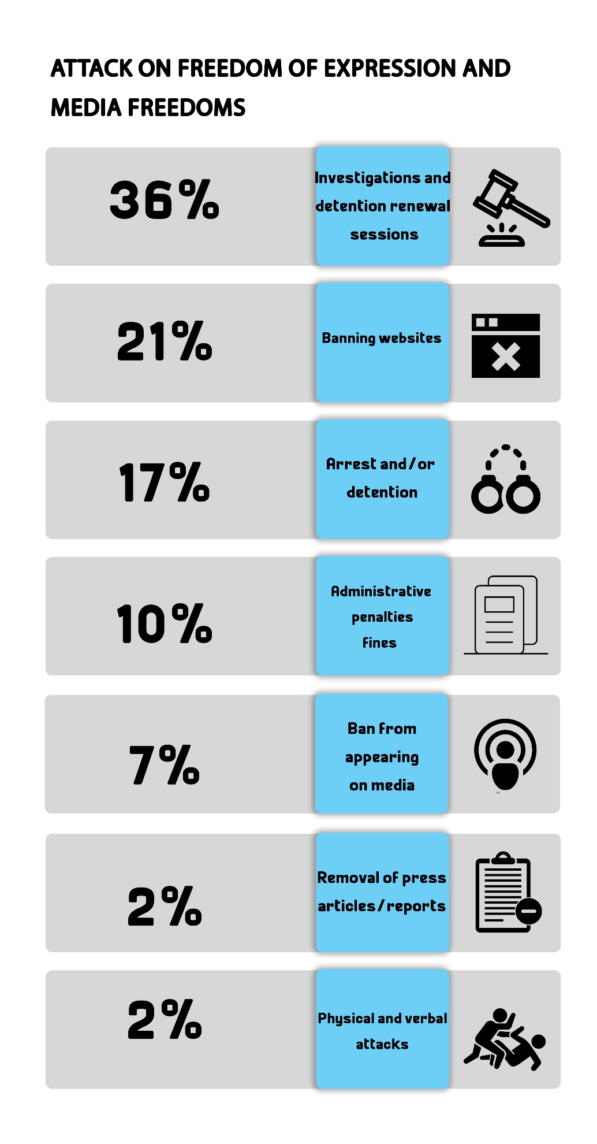
Fifth: Attack on Human Rights Defenders:
- On 4 April 2020, Cairo Criminal Court postponed the consideration of the detention renewal of human rights lawyer Mohamed al-Baqir and activist Alaa Abdel-Fattah pending the Case No. 1356 of 2019 State Security, in which they are charged with joining a terrorist group, committing one of funding-related crimes, spreading and broadcasting false news and statements, and misusing the Internet. The case was adjourned for the hearing of 18 April due to the inability to transfer the two defendants from their jail to the courthouse. On 5 May, Giza Criminal Court decided to renew their detention of the two human rights defenders for further 45 days.

- On 4 April 2020, Cairo Criminal Court postponed the consideration of the detention renewal of human rights lawyer Mahinour El-Masry pending the Case No. 488 of 2019 State Security, on charges of abetting a terrorist group to achieve its goals, spreading false news and statements, and misusing social media. The case was adjourned for the hearing of 18 April due to the inability to transfer her from her jail to the courthouse. On 5 May 2020, Giza Criminal Court decided to renew El-Masry's detention for 45 days. The following day (6 May) the same court extended the lawyer's detention for further 45 days.

- On 4 March 2020, Cairo Criminal Court decided to adjourn the detention renewal of human rights lawyer Haytham Mohamadein pending case No. 741 of 2019 State Security, on charges of colluding with a terrorist group to achieve its goals and spreading false news and statements. The case was postponed for the hearing of April 18, 2020 due to the inability to transfer the defendant from his jail to the courthouse. On 3 May 2020, Giza Criminal Court renewed Mohamadein's detention for 45 days. On 7 May 2020, his detention was renewed for further 45 days by the same court.

- On 9 April 2020, the Supreme State Security Prosecution decided to renew the detention of lawyer Mohsen Bahnasi- without being appeared before the Prosecution- for 15 days pending the Case No. 558 of 2020 State Security on charges of joining a terrorist group, spreading false news and statements and misusing social media. On 29 April, the State Security Prosecution extended the lawyer's detention for 15 days, which was extended for further 15 days by the Prosecution on the 6th of May 2020.

- On 12 April 2020, the Court of Administrative Justice decided to postpone the appeal No. 31973 of 73 (judicial year) filed by Hisham Jafar, journalist and head of 'Mada' Foundation for Media Development, challenging his exclusion from the Journalists Syndicate's mid-term elections. The appeal was administratively postponed to a hearing to be set later, in implementation of the State Council head's decision to suspend court proceedings.

- On 21 April 2020, Cairo Criminal Court ordered the continuation of precautionary measures (appearing before the police station one day a week for 2 hours) issued against Hisham Jafar, journalist and head of 'Mada' Foundation for Media Development, for 45 days pending case No. 720 of 2015 State Security, in which he faces charges of joining a terrorist group and receiving international bribery.

- On 23 April 2020, South Cairo Criminal decided to adjourn the sentencing hearing in the appeal filed by 11 human rights defenders for the hearing of 18 June 2020. The appeal challenges the travel- ban decision issued against them by the investigating judge presiding over the case known in the media as "closure of the civil society".

- On 3 May 2020, Giza Criminal Court renewed the detention of human rights lawyer Sayed al-Banna, Dr. Walid Shawki and linguist Ayman Abdel-Moati- without bringing them from their jail- for 45 days pending the case No. 621 of 2018 State Security, in which they face charges of joining a terrorist group and spreading false news and statements.

- On 4 May 2020, the Supreme State Security Prosecution interrogated activist Marwa Arafa and ruled to hold her in detention for 15 days pending the Case No. 570 of 2020 State Security, after charging her with joining a terrorist group with the knowledge of its purposes and committing a crime of financing of terrorism.

- On 4 May 2020, Giz Criminal Court renewed the detention of engineer Yehia Hussein Abdel Hady for further 45 days pending investigations into the Case No. 277 of 2019 State Security, in which he is accused of colluding with a terrorist group to achieve its goals and spreading and broadcasting false news and statements.

- On 4 May 2020, Giza Criminal Court renewed the detention of journalist and activist Israa Abdel-Fattah – without bringing her from her jail- for 45 days pending the Case No. 488 of 2019 State Security, on charges of colluding with a terrorist group to achieve its goals, publishing and broadcasting false news and statements, and misusing social media.

- On 5 May 2020, Giza Criminal Court renewed the detention of journalists Khaled Daoud, Hossam al-Sayyad and Solafa Magdy- without bringing them from their jail to the courthouse- for 45 days pending the Case No. 488 of 2019 State Security, on charges of abetting a terrorist group to achieve its goals, spreading false news and statements, and misusing social media. On 6 May 2020, Giza Criminal Court renewed the detention of journalists Khaled Daoud- without bringing him from his jail- for further 45 days pending the aforementioned case and charges.

- On 6 May 2020, Giza Criminal Court decided to renew the detention of human rights lawyer Zyiad Elelaimy and journalists Hossam Moanis and Hisham Fouad- without bringing them from their jail to the courthouse- for 45 days, pending the Case No. 930 of 2019 State Security, in which they face charges of abetting a terrorist group in achieving its goals and spreading false news and statements.

- On 14 May 2020, the Court of Administrative Justice decided to postpone the appeal No. 39418 of 73 (judicial year) filed by human rights lawyer Gamal Eid and journalist Khaled Balshi challenging the list of sanctions and regulations of the Law Regulating the Press and Media. The appeal was postponed to the hearing of the first of June, 2020.

- On 17 May 2020, Cairo Criminal Court decided to postpone the consideration of the detention renewal of human rights lawyer Amr Imam, journalists Israa Abdel-Fattah, Solafa Magdy and Hossam al-Sayyad pending the Case No. 488 of 2019 State Security, in which they face charges of colluding with a terrorist group to achieve its goals, publishing and broadcasting false news and statements, and misusing social media. The case was postponed to the hearings of the first and the second of June 2020, due to the inability to transfer the defendants from their jail to the courthouse.

- On 17 May 2020, the security forces in charge of securing the Tora Prison Complex arrested journalist and editor-in-chief of Mada Masr Lina Attalah, from outside Tora Prison, where she had been interviewing Laila Soueif. A report had been filed, registered under No. 8009 of 2020 Maadi Misdemenour, before she was referred to the Public Prosecution which ordered her release on bail of EGP 2000 after accusing her of "filming a military facility without permit".

- On 20 May 2020, the security forces arrested journalist and researcher Shaimaa Samy from her house in Alexandria and took her to an unknown destination and during this period she hadn’t appeared before any investigating authority, until on 30 March 2020, the Supreme State Security Prosecution interrogated Shimaa over the Case No. 535 of 2020 State Security on charges of: joining a terrorist group with knowledge of its goals, misusing social media, and spreading false news and statements. Shaimaa was then ordered to be held for 15 days in pretrial detention. On 10 June, the Prosecution ruled to extend the detention of the journalist for 15 days, and on the 22th of the same month, her detention was renewed for further 15 days.

- On 30 May, the Court of Administrative Justice ruled that it has no jurisdiction over the appeal No. 63216 of 71 (judicial year) filed by human rights lawyer Gamal Eid and Dr. Aaida Seif El-Dawla along with other human rights defenders, challenging the decision issued by Cairo Court of Appeal's president ordering that the investigating judge of the case known in the media as "closure of the civil society" would continue to be mandated to preside over the case.

- On 3 June 2020, Giza Criminal Court renewed the detention of lawyer Sahar Ali for 45 days pending the Case No. 1358 of 2019 State Security, on charges of abetting a terrorist group to achieve its goals, committing one of financing-related crimes, and spreading and broadcasting false news and statements.

- On 4 June 2020, Giza Criminal Court renewed the detention of lawyer Ibrahim Metwaly, founder of the Association of the Families of the Disappeared, for 15 day pending case No. 1470 of 2019 State Security, on charges of joining a terrorist group, committing crimes of terrorism funding, and spreading false news and statements.

- On 14 June 2020, Alexandria Criminal Court renewed the detention of human rights lawyer Mohamed Ramadan for further 45 days pending the Case No. 16576 of 2018 Montazah Administrative, aka "yellow vests" case, on charges of joining a terrorist group, spreading false news and statements and inciting to protest.

- On 20 June 2020, Dr. Laila Soueif organized a sit-in outside the Tora Prison Complex, after the prison's authorities refused to give her a letter from her son Alaa Abdel-Fattah who is being detained at a high-security warden in Tora prison 2 pending the Case No. 1356 of 2019 State Security. The security forces had detained Soueif before they released her later.
---------------------------------------------------------
Note: This report is based on the cases monitored by ANHRI and does not necessarily include all the incidents took place throughout the month.
To view the previous Democratic Path reports:
To view the Democratic Path Report in 2014, “Obscure and stalled”
To view the Democratic Path Report in 2015, “One step back, two steps further back”
To view the Democratic Path Report in 2016 “Closed until further notice”
To view the Democratic Path Report in 2017, “Very Steep”
To view the Democratic Path Report in 2018, “Mounting Anger".
Less Hope, More Despair…The Democratic Path in Egypt 2019

