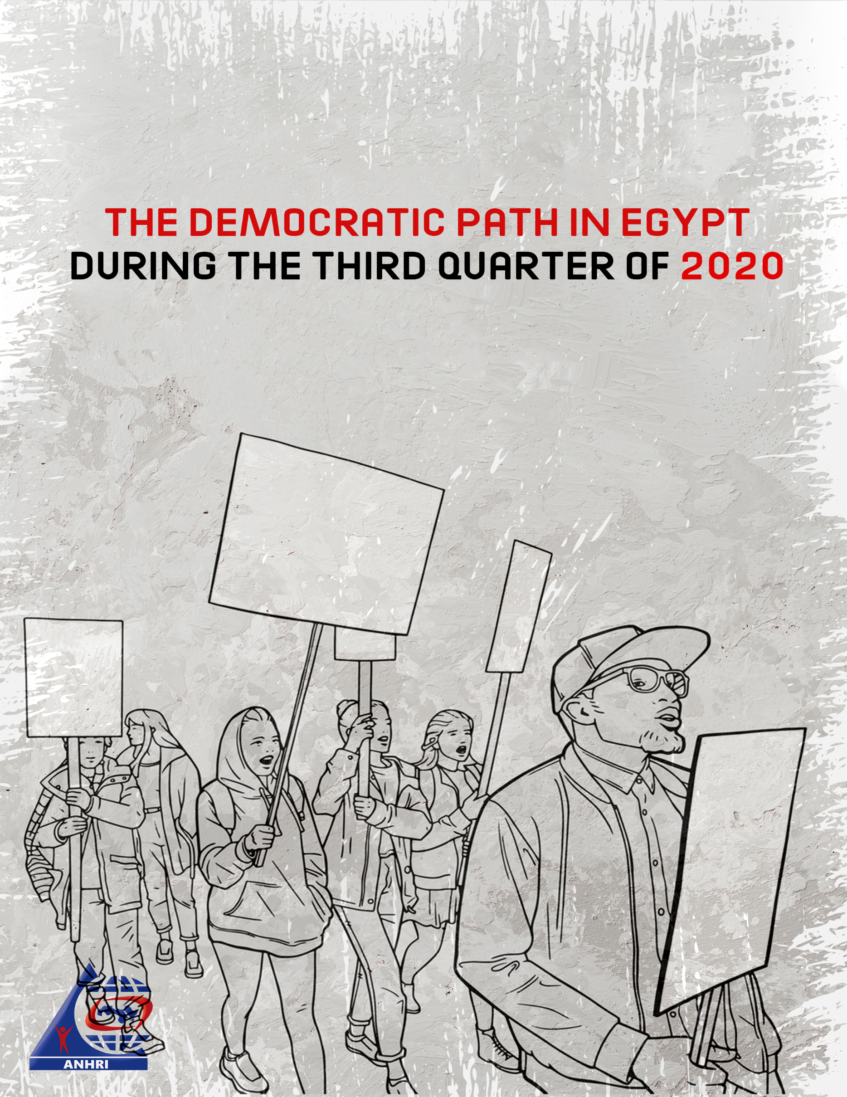

The Arabic Network for Human Rights Information (ANHRI)
"Lawyers for Democracy” Initiative

The Democratic Path in Egypt during the Third Quarter of 2020 (1)

Introduction
This is the third Democratic Path report released by the Arabic Network for Human Rights Information (ANHRI) throughout 2020. Political incidents escalated in the last month of the period covered by the report. For the second year in a row, thousands of citizens took to the streets – in what is known in the media as ‘September 20 Protests’ - to protest the economic policies adopted by the state and to reject to a bunch of laws passed by the legislative authority, on top of which is the Reconciliation Law on Building Violations.
Security crackdown against human rights defenders continued during the reporting period, when the State Security Prosecution interrogated a number of lawyers, human rights defenders and activists over new cases despite being held in pretrial detention, accusing them of communicating with each other with the aim of committing terrorist crimes although they are being detained at different prisons. Among the most prominent of those investigated were: human rights lawyers Amr Imam, Mohamed al-Baqir, and Mahinour al-Masri, and journalists Solafa Magdy and Israa Abdel Fattah. Additionally, the Egyptian judiciary has turned down the appeal submitted by 13 human rights defenders challenging the travel ban decision issued by the investigating judge in the case known in the media as ‘The closure of civil society’.
The reporting period also witnessed the resumption of trial sessions while following the precautionary measures to limit the spread of COVID-19 after 3-month suspension.

The report can be summarized in number as follows:
- Number of protests during the reporting period: 131
- Number of trials during the reporting period: 42, including 3 military trials
- Number of civilians brought to trial before military courts: 996 citizens.
- Number of violations against media freedoms and freedom of expression: 38
- Number of people sentenced to death during the reporting period: 15 citizens, throughout 3 trials.

The details of the state of the democratic path during the 2nd quarter of 2020 are outlined, in numbers and percentages, as follows:
First: Protest events
During the third quarter of the year, the various forces organized 131 different events, and their distribution was as follows:
* Social and labor protests: 50 protest events
* Muslim Brotherhood (MB) and the National Alliance to Support Legitimacy (NASL): 23
* Student protests: 5
* Pro-regime protests: 4
* Unclassified protest events: 49
The following table shows the percentage of protest activities according to the organizing forces
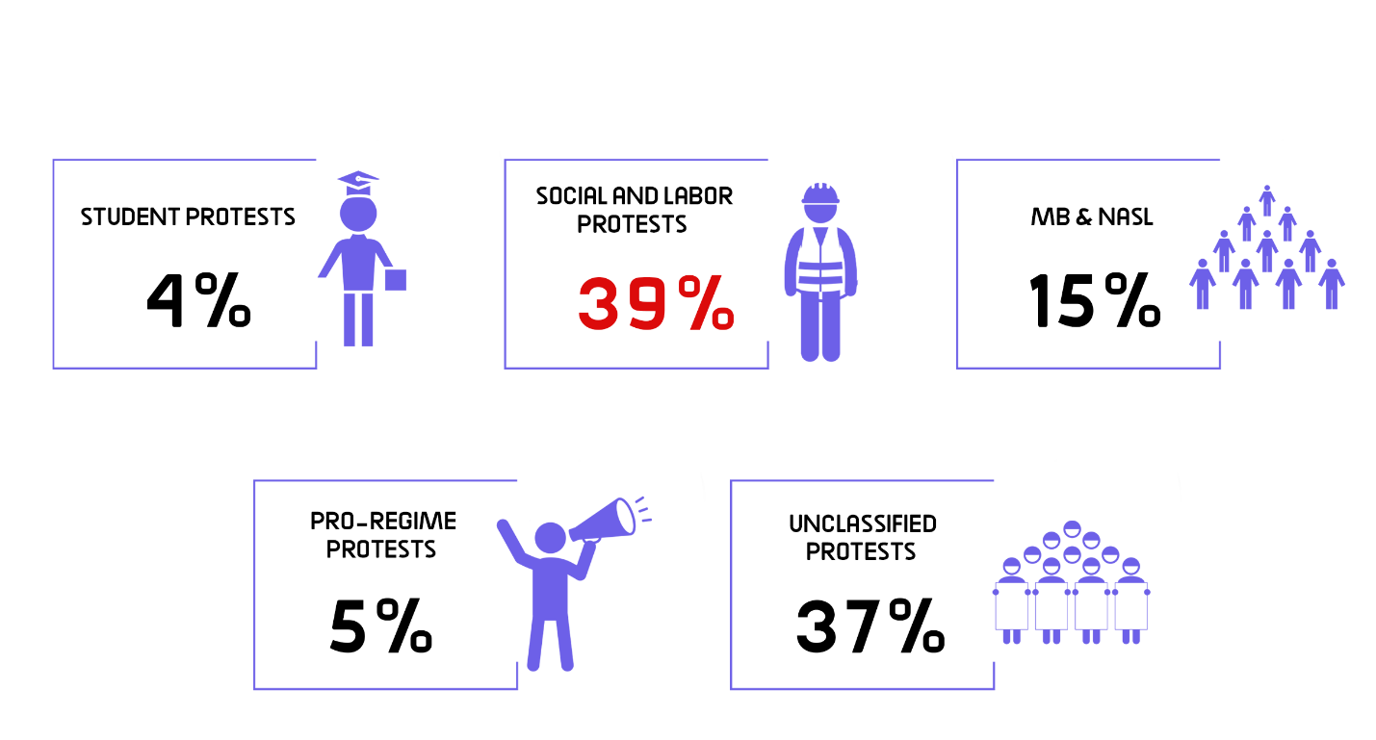
The month of September came first in witnessing the largest number of protest events with 29 different protests, as shown in the following table:
July | August | September | Total
32 | 31 | 68 | 131

Out of these different events, 57 were attacked by security forces, 65 passed without attacks, and 9 labor and social protests were resolved after negotiations.
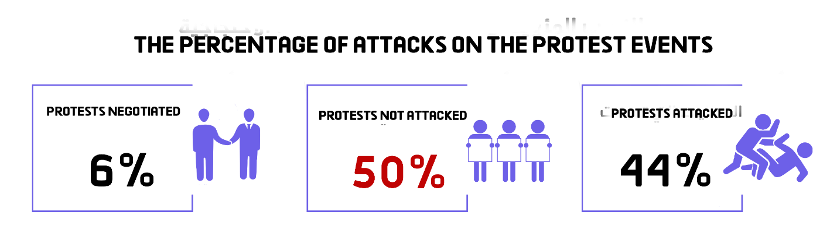

Labor and Social protests:
The third quarter of 2020 witnessed 50 different social and labor protests; five of which were attacked by security forces, whereas 36 passed without interference, and 9 were resolved after negotiations with their organizers.
The most important demands brought by the social and labor protests:
- A number of workers protested their arbitrary dismissal from work and demanded the disbursement of their financial dues
- A number of workers demanded installation in their jobs
- A number of citizens protested the demolition of their houses objecting to Reconciliation Law on Building Violations
- A number of nurses and medical staff protested the health conditions in hospitals and demanded to conduct a coronavirus test for them.

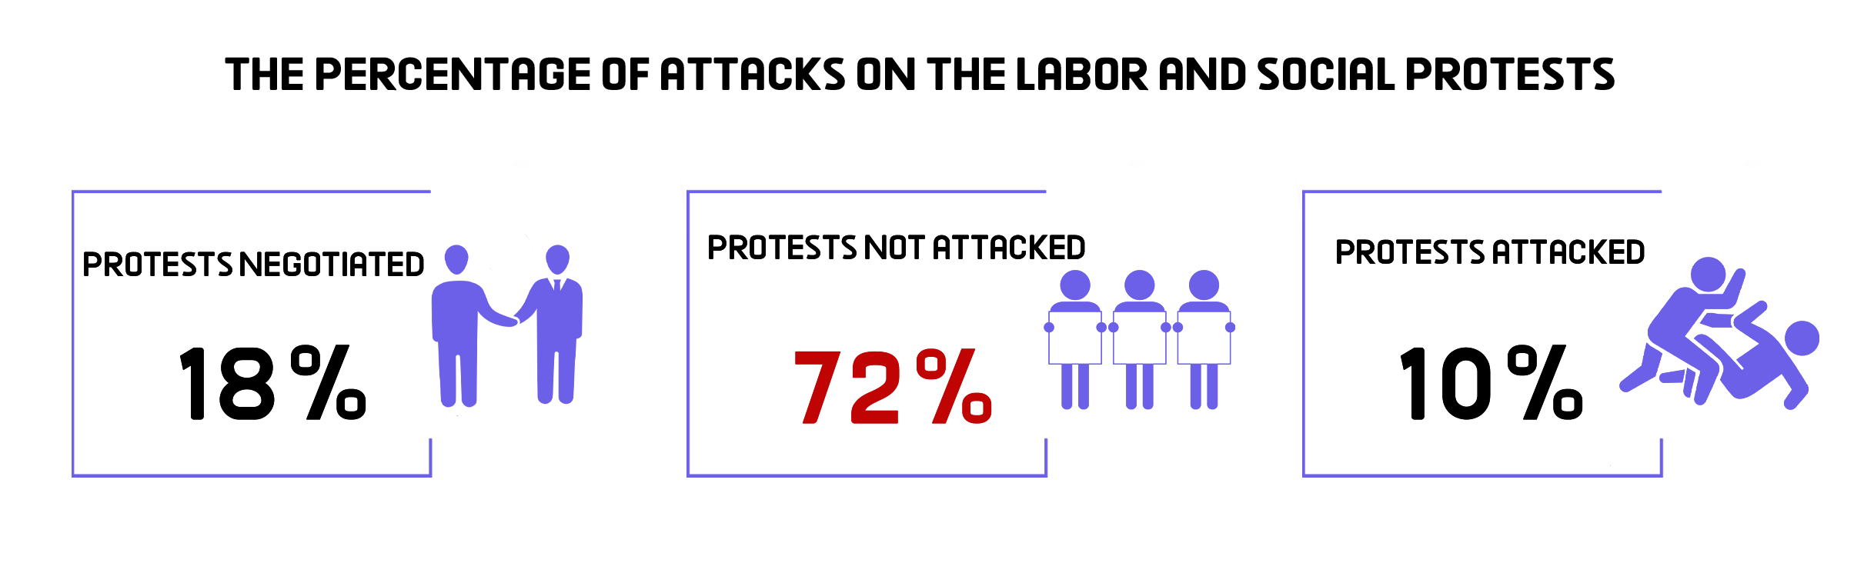
MB and NASL protest activities:
The third quarter of 2020 witnessed a continued decline in the protest activities organized by the Muslim Brotherhood (MB) and the National Alliance to Support Legitimacy (NASL); and this is due to the alliance’s fear of arrest especially after the arrest of the MB deputy guide Mahmoud Ezzat. During the reporting period 23 different protests were staged, including three that were attacked by the security forces and 20 that were left without security intervention, while none of them was subject to negotiation.
The most important demands raised by Muslim Brotherhood and the National Alliance to Support Legitimacy:
- Demanding the release of detainees and improvements to prison conditions.
- Demanding to topple what they described as the military rule.
- Denouncing the arrest of MB deputy guide Mahmoud Ezzat

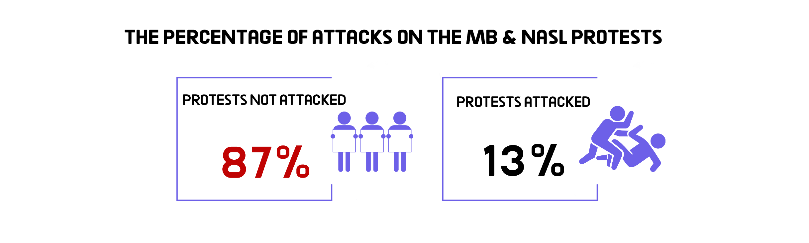
Student activities:
The third quarter of the year witnessed student organizing 5 protest events all of which hadn’t been dispersed by the security forces.
Student protests’ main demands:
- A number of high school students objected to the difficulty of the physics exam.
- A number of high school students objected to the results of their exams and their academic grievance.

Pro-regime protest events:
The third quarter of 2020 witnessed four protests supporting the regime and the state’s decisions, and all of them hadn’t faced any sort of intervention by the security forces.
Unclassified Protests (September 20 incidents):
The last month of the third quarter of 2020 witnessed thousands of citizens who are not affiliated with any political faction organizing protest events on September 20, in what is dubbed in media as ‘September 20 incidents’. About 49 protest events all over Egypt’ various governorates had been staged, during which the security forces arrested hundreds of citizens and referred them to the Supreme State Security Prosecution which interrogated them over Case No. 880 of 2020 State security on charges of: Colluding with a terrorist group to achieve its goals, spreading false news and statements, misusing social media, joining a gathering with the aim to commit acts of violence.

Second: Trials
- Ongoing trials:
The third quarter of 2020 witnessed 42 trial cases that are being considered before the Egyptian judiciary. Of these, there were 17 rulings of conviction, four acquittals and three death sentences against 15 defendants.
The distribution of the 42 ongoing trials is as follows:
* 28 trials for the MB & NASL.
* 6 trials of the civil and democratic powers.
* 4 trials for Mubarak’s regime’s affiliates.
* 1 trial in other cases
* The military judiciary considered 3 trials for 996 civilians

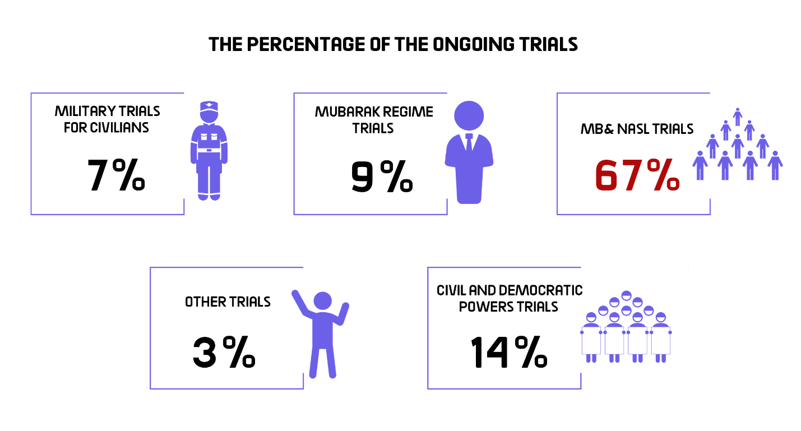
The most prominent trials of MB and NASL are:
The cases known in the media as: (Isis-October, Isis-First Settlement, Isis- Upper Egypt, Rabaa Sit-in dispersal,, arson of Al-Atamna Police Station, arson of Kafr Hakim Church, Helwan Brigades, Al-Nusra Front, Al-Moski violence incidents, raiding Al-Arab Police Station, May 15 violence incidents, raiding Al-Tebbein Police Station, Al-Masara Cell, raiding Kerdasa Police Station, Al-Maghara incidents)
The most prominent trials of Mubarak regime figures are:
The cases known in the media as: (The Green Belt, customs corruption, the License Plates and Gas coupons).
The most prominent trials of civil and democratic powers are:
The cases known in the media as: (The Oppressed of Downtown, The trial of Al-Warraq Island residents, The Cabinet incidents, Trial of lawyer Zyiad El-Eleimy, the seizure of Dr. Hassan Nafaa's funds, and the trial of engineer Mamdouh Hamza).
The most prominent trials of post- June 30th regime’s affiliates are:
The cases known in the media as: (The Great Wheat Corruption)
The Military Trials of civilians:
In the third quarter of 2020, the military judiciary considered 3 ongoing trials for 996 civilians.
- Sentences
During the reporting period, there were 22 convictions and 4 acquittals. The details are as follows:
Convictions:
During the third quarter of the year, the Egyptian judiciary issued 22 convictions, distributed as follows:
* 18 rulings against the Muslim Brotherhood (MB) and the National Alliance for the Support of Legitimacy (NASL).
* Two rulings against Mubarak regime’s figures
* One ruling against defendants in the civil democratic forces’ cases
* One ruling against June 30-regime’s supporters
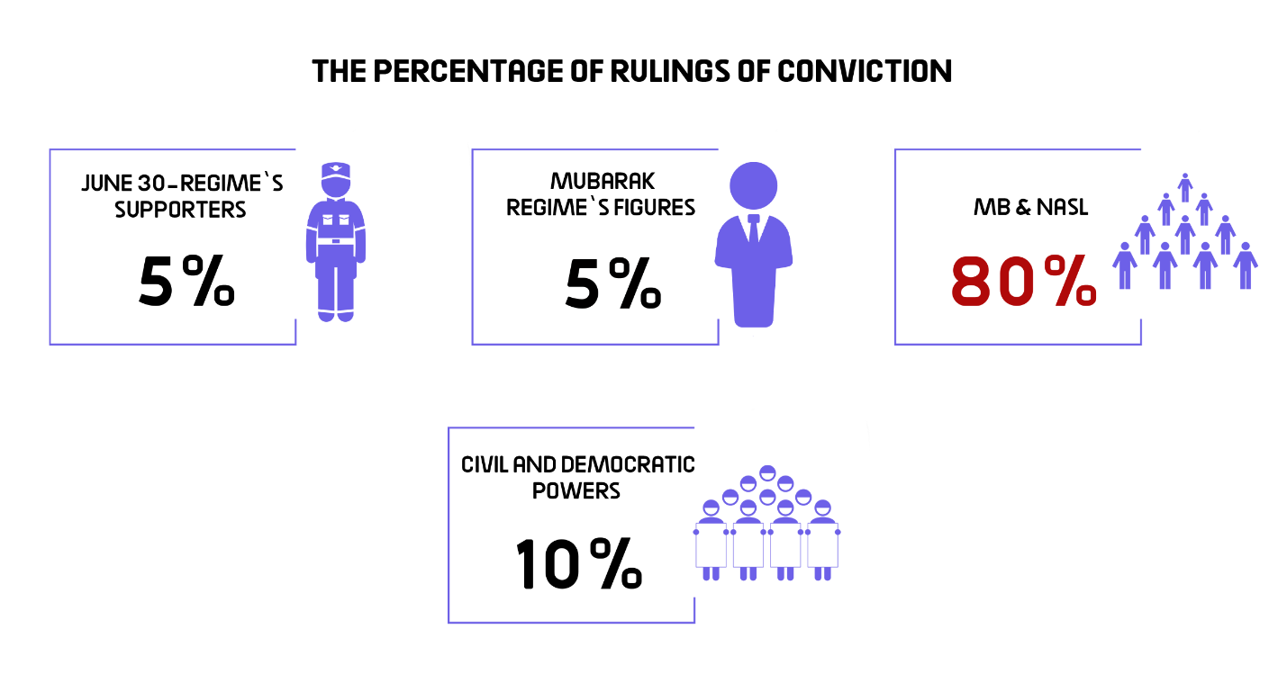
Acquittals:
During the third quarter of the year, four acquittals had been handed down for the MB and NASL affiliates, in addition to two rulings of acquittal for Mubarak regime’s figures.
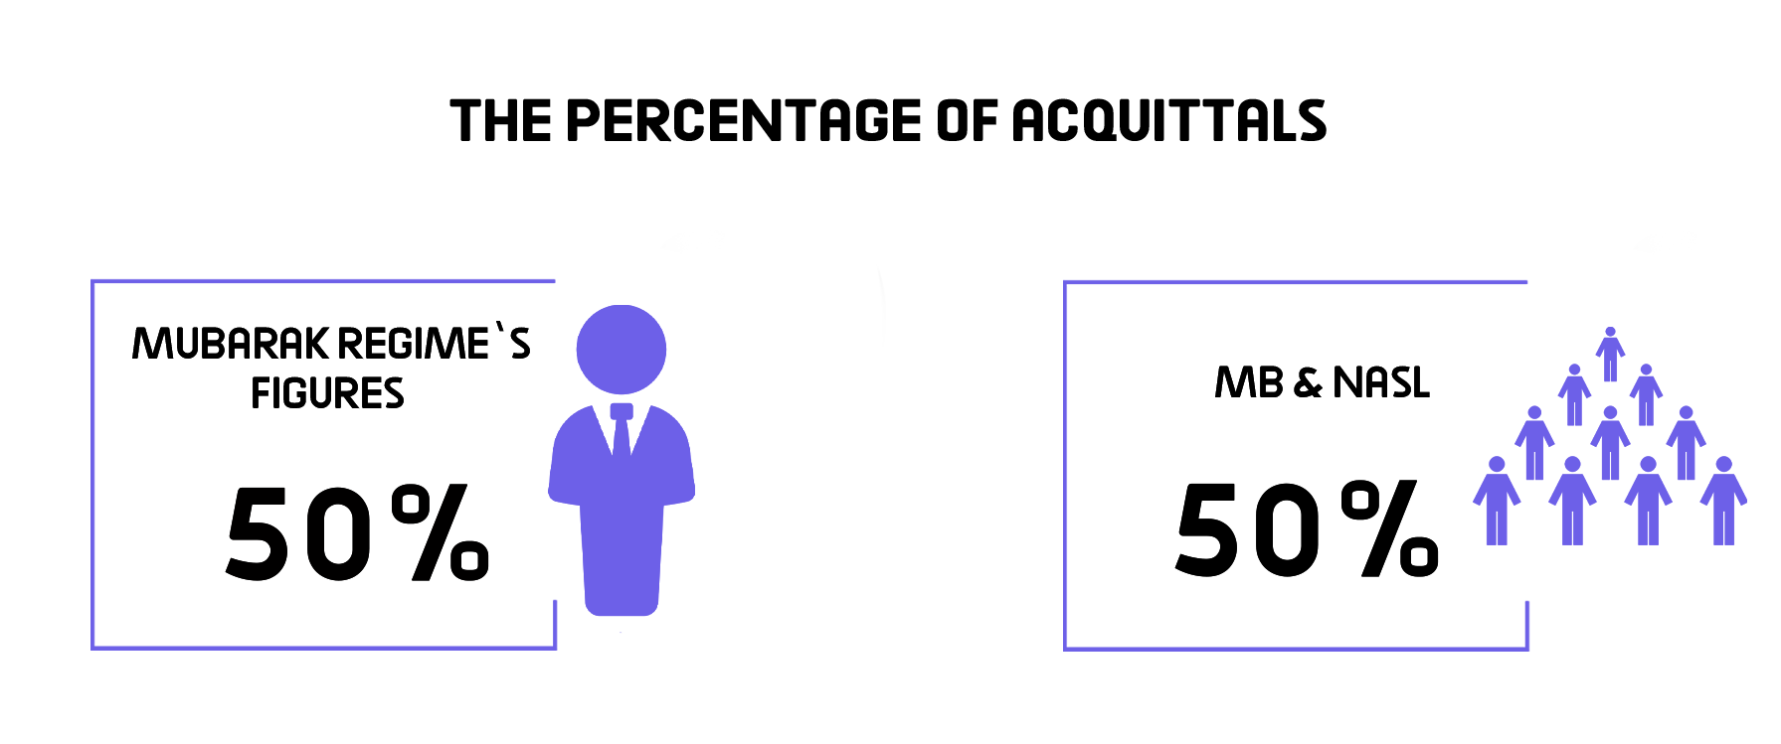

Death sentences
Three death sentences were issued against 15 defendants during the third quarter of 2020, in addition to the execution of 7 defendants convicted of killing Sergeant Ahmed Abu Douma, assistant detective of Ismailia 3rd Police Station in 2013, as shown in the following table:

1- Rulings
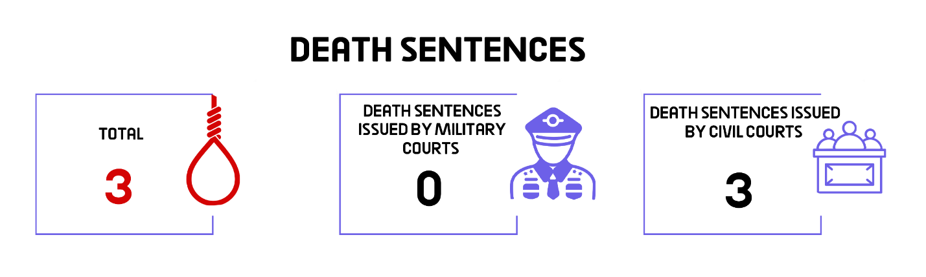
2- Defendants
Total (Number of defendants) | Number of defendants upheld by the Court of Cassation to be executed | Number of defendants upheld by the Mufti to be executed | Number of defendants referred to the Mufti
15 | 9 | 6 | -- | Civil
-- | -- | -- | -- | Military
15 | 9 | 6 | -- | Total

3- Death sentences executed:
The Prisons Authority sector executed, in the month of July, one death sentence handed down against one defendant:
On 28 July 2020, the Prisons Authority sector carried out the death sentence that was issued by Ismailia Criminal Court against 7 defendants after being convicted of killing Sergeant Ahmed Abu Douma, assistant detective of Ismailia 3rd Police Station in 2013.

Third: Violence and Terrorism
The third quarter of 2020 witnessed a total of 8 terrorist operations that took place in North Sinai governorate, along with 16 counter-terrorism operations, detailed as follows:
- Terrorist operations:
Eight terrorist attacks took place in the third quarter of the year; 7 of them had been carried out, while the security forces succeeded in thwarting only one. The operations resulted in the killing and injury of 43 people.
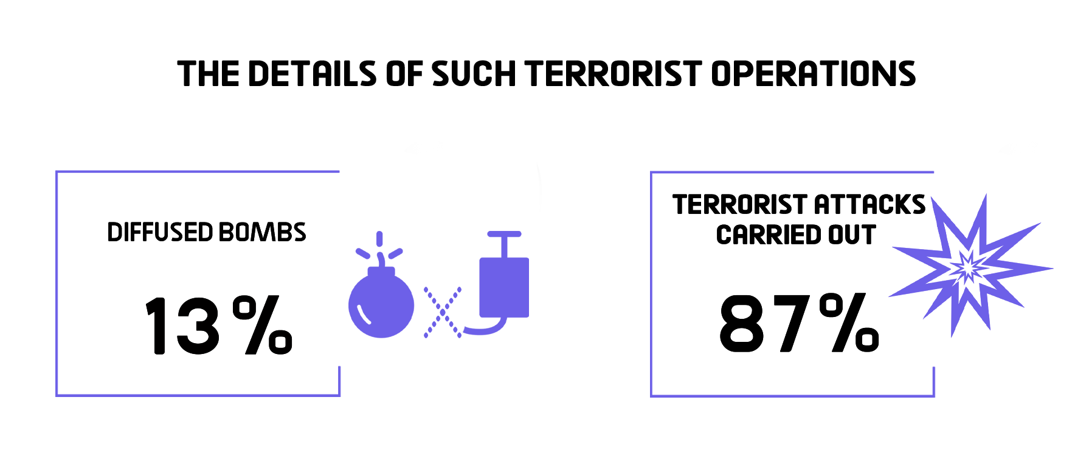
The following table shows the percentage of terrorist operations and counter-terrorism ones:
Total | Operations thwarted | Operations carried out | Months
3 | 1 | 2 | July
3 | 0 | 3 | August
2 | 0 | 2 | September
8 | 1 | 7 | Total

The following table shows the number of terrorist operations and their distribution in the different governorates:
Total | Operations thwarted | Operations carried out | Governorates
8 | 1 | 7 | North Sinai
8 | 1 | 7 | Total

– These operations had resulted in 43 killed and wounded.
The following table shows the number of killed and wounded and their distribution:
Total | Terrorists | Security forces | civilians
21 | 0 | 20 | 1 | Number of killed
22 | 0 | 22 | 0 | Number of wounded
43 | 0 | 42 | 1 | Total

- Counter-Terrorism Operations
During the third quarter of the year, there were 16 preemptive attacks by the security forces which targeted what they described as terrorism hubs, resulting in the killing of 120, the wounding of 7 and the arrest of 35 others.
The following table shows the number of dead and injured
Total | Those targeted | Security forces
120 | 112 | 8 | Number of killed
7 | 6 | 1 | Number of wounded
127 | 118 | 9 | Total

Fourth: Attack on Freedom of Expression and Media Freedoms
The third quarter of the year witnessed 38 various violations against freedom of expression and media freedoms.
The following table shows the number of violations took place throughout the 3rd quarter of 2020:
Months | Number of violations
15 | July
10 | August
13 | September
38 | Total during the 3rd quarter of 2020

Details are as follows:

Number of violations | Kind of violation
16 | Investigations and detention renewal sessions
6 | Coverage ban
5 | Arrest and/or detention
3 | Physical and verbal attacks
3 | Administrative penalties (fines)
2 | Administrative investigations
2 | Complaints with the Public Prosecutor
1 | Publication ban
38 | Total of violations

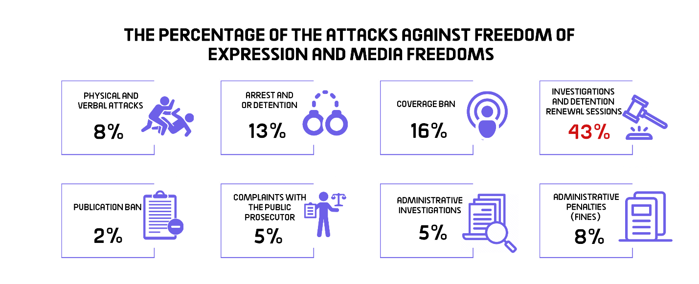
Fifth: Attack on Human Rights Defenders:
1-On 1 July 2020, Cairo Criminal Court adjourned the detention renewal of human rights lawyer Sayed al-Banna, Dr. Walid Shawki and linguist Ayman Abdel-Moati pending the Case No. 621 of 2018 State Security, in which they face charges of joining a terrorist group and spreading false news and statements. The case was postponed for the hearing of 15 July 2020 due to the inability to transfer the defendants from their jail to the courthouse. On the 15 July hearing, the court decided to renew the detention of the three activists for 45 days. Then on August 23, the same court replaced the activists’ pretrial detention with precautionary measures, without releasing them from jail, rather, both Ayman and Sayed were recycled into a new case; Case No. 880 of 2020 State Security.
2- On 5 July 2020, Cairo Criminal Court decided to postpone the consideration of the detention renewal of human rights lawyer Amr Imam, journalists Israa Abdel-Fattah, Solafa Magdy and Hossam al-Sayyad pending the Case No. 488 of 2019 State Security, in which they face charges of colluding with a terrorist group to achieve its goals, publishing and broadcasting false news and statements, and misusing social media. The case was postponed to the hearing of 19 July 2020, due to the inability to transfer the defendants from their jail to the courthouse. Then, on 19 July 2020, the court renewed the defendants’ detention for 45 days which was extended for further 45 days on the session set on August 25.
3- On 6 July 2020, the Supreme State Security Prosecution decided to renew the detention of human rights lawyer Mohsen Bahnasi for 15 days pending the Case No. 558 of 2020 State Security on charges of joining a terrorist group, spreading false news and statements and misusing social media. Then, on the 20 July session, the Prosecution renewed the lawyer’s detention for 15 days, which was extended for further 15 days on the session of August 8, before the court decided to replace his pretrial detention with precautionary measures on the session of 23 August.
4- On 7 July 2020, the Supreme State Security Prosecution decided to renew the detention of journalist and researcher Shaimaa Samy- without appearing before the prosecutor- for 15 days pending the Case No. 535 of 2020 State Security, in which she is charged with joining a terrorist group with knowledge of its goals, misusing social media, and spreading false news and statements. Then on 22 July, the Prosecution extended the researcher’s detention for 15 days pending the same aforementioned case and charges.
5- On 12 July 2020, Cairo Criminal Court decided to renew the detention of human rights lawyer Mohab al-Ebrashi for 45 days pending the Case No. 1898 of 2019 State Security, in which he is charged with joining a terrorist group, misusing social media and spreading false news and statements.
6- On 14 July 2020, Cairo Criminal Court renewed the detention of engineer Yehia Hussein Abdel Hady for further 45 days pending investigations into the Case No. 277 of 2019 State Security, in which he is accused of colluding with a terrorist group to achieve its goals and spreading and broadcasting false news and statements. On 31 August, the court extended the engineer’s defendant for 45 days.
7- On 14 July 2020, Cairo Criminal Court ordered the continuation of the precautionary measures (appearing before the police station one day a week for 2 hours) issued against Hisham Jafar, journalist and head of 'Mada' Foundation for Media Development, for 45 days pending case No. 720 of 2015 State Security, in which he faces charges of joining a terrorist group and receiving international bribery.
8- On 18 July 2020, South Cairo Criminal Court turned down the appeal filed by 14 human rights defenders challenging the travel ban order issued against them by the investigating judge mandated to consider the case known in the media as "the closure of the civil society".
9- On 19 July 2020, the Supreme State Security Prosecution renewed the detention of activist Sanaa Seif- without bringing her from her jail- for 15 days pending Case No. 659 of 2020 State Security, on charges of: incitement of terrorist crimes, publishing and broadcasting false news and statements that call for disturbing public security, misuse of social media, and using the internet to promote views calling for terrorist acts. On 28 July 2020, the Prosecution renewed the detention of the human rights activist for 15 days- without appearing before the prosecutor- pending the aforementioned cases and charges. Then on 12 September 2020, Cairo Criminal Court adjourned the activist’s first trial hearing for September 17 due to the inability to bring her from her jail to the courthouse. On the September 17 hearing, the court postponed the trial for the hearing of 11 October 2020.
10- On 25 July 2020, Cairo Criminal Court decided to renew the detention of human rights lawyer Haytham Mohamdein for 45 days pending Case No. 741 of 2019 State Security, in which he is accused of colluding with a terrorist group to achieve its goals and spreading false news and statements.
11- On 25 July 2020, Cairo Criminal Court decided to renew the detention of human rights lawyer Zyiad Elelaimy and journalists Hossam Moanis and Hisham Fouad for 45 days, pending Case No. 930 of 2019 State Security, in which they face charges of abetting a terrorist group in achieving its goals and spreading false news and statements.
12- On 26 July 2020, Cairo Criminal Court renewed the detention of journalist Khaled Daoud and human rights lawyer Mahinour El-Masry for 45 days pending the Case No. 488 of 2019 State Security, on charges of abetting a terrorist group to achieve its goals, spreading false news and statements, and misusing social media.
13- On 27 July 2020, Cairo Criminal Court decided to renew the detention of human rights lawyer Mohamed al-Baqir and bloggers Alaa Abdel-Fattah and Mohamed Oxygen for 45 days pending Case No. 1356 of 2019 State Security, in which they are charged with abetting a terrorist group to achieve its goals, committing one of funding-related crimes, spreading and broadcasting false news and statements.
14- On 8 August 2020, the Court of Administrative Justice decided to adjourn the appeal No. 7720 of 72 ( judicial year) submitted by human rights lawyer Gamal Eid challenging the travel ban issued against him, for the hearing of 19 September 2020.
15- On 23 August 2020, Cairo Criminal Court decided to renew the detention of journalist Israa Abdel-Fattah for 45 days pending Case No. 488 of 2019 State Security, in which she faces charges of colluding with a terrorist group to achieve its goals, publishing and broadcasting false news and statements, and misusing social media.
16- On 26 August 2020, the Supreme State Security Prosecution interrogated human rights lawyer Amr Imam over a new case; No. 855 of 2020 State Security, on charges of joining a terrorist group, receiving funding with the aim of committing a terrorist crime. The Prosecution accordingly decided to renew his detention for 15 days over the new case following the end of his detention over the Case No. 488 of 2019.
17- On 31 August 2020, the Supreme State Security Prosecution interrogated human rights lawyer Mohamed al-Baqer and journalist Israa Abdel-Fattah into Case No. 855 of 2020 on charges of colluding with a terrorist group to achieve its goals and committing one of funding-related crimes. The Prosecution then decided to hold them in pretrial detention for 15 days that would start after serving their detention period over the pending cases.
18- On 17 September 2020, the Supreme State Security Prosecution investigated human rights lawyer Sayed al-Banna and linguist Ayman Abdel-Moati over Case No. 880 of 2020 State Security on charges of joining a terrorist group, misusing social media, and spreading false news and statements. The Prosecution then ruled to hold them in pretrial detention for 15 days pending probe, despite the fact that they had illegally been held in an unknown place for 15 days since their release order issued over Case No. 621 of 2018 State Security at the August 23 session.
---------------------------------------------------------
Note: This report is based on the cases monitored by ANHRI and does not necessarily include all the incidents took place throughout the month.
To view the previous Democratic Path reports:
To view the Democratic Path Report in 2014, “Obscure and stalled”
To view the Democratic Path Report in 2015, “One step back, two steps further back”
To view the Democratic Path Report in 2016 “Closed until further notice”
To view the Democratic Path Report in 2017, “Very Steep”
To view the Democratic Path Report in 2018, “Mounting Anger".
Less Hope, More Despair…The Democratic Path in Egypt 2019
_____________________________________________________________________________________________________
(1)- The Democratic Path is a report launched by the Arabic Network for Human Rights Information (ANHRI) in 2014. It is now released every three months, i.e. quarterly, but ANHRI used to publish it on a monthly basis during the previous years through the “Lawyers for Democracy” initiative.
In addition to the monthly reports issued to monitor the state of democracy, ANHRI issued annual reports to monitor the democratic path, which can be accessed through the “Reports” section on ANHRI’s website by clicking on the following link:
https://www.anhri.info/?cat=14&lang=en
Note: This report is based on the cases monitored and documented by the “Lawyers for Democracy” initiative’s team and does not necessarily include all the incidents took place throughout the reporting period.

